***What’s in it for you?***

**USATF Officials Certification Benefits**

* Nationally recognized USATF certification
* Certified official photo ID card and pin
* Insurance – liability coverage (bodily/personal injury, property damage, and legal representation) for officials or volunteers at any organized competition (sanctioned or not)
* Access to officials’ training materials and training clinics
* Eligibility to officiate at USATF national championships and other major competitions

**USATF Membership Benefits**

* Eligibility for USATF officials’ certification
* Eligibility to compete in USATF sanctioned competitions
* Insurance - accidental bodily injury and death coverage during travel to/from and participation in USATF sanctioned meets and USATF club practices
* Subscription to USATF magazine “Fast Forward”
* Discounts on logo merchandise from the USATF online store
* Discounts on running merchandise, books, magazines, and videos
* Discounts on hotels and car rentals

The

[ Xxxxxxxxx ] Association

invites you to

**Join Us!**

as we support track and field for youth, open, masters and ability athletes both locally and nationally!

For more information,

contact our Officials’ Chair:

[name]

[[email](mailto:bdlong2@verizon.net) address]

[Phone number]

[[association](http://www.usatf.org/assoc/threerivers/) website]

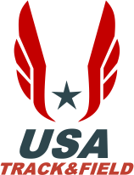



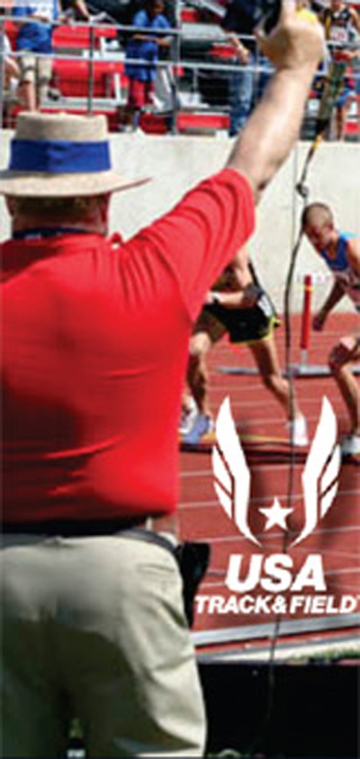

**Become a**

**USA Track & Field**

**Certified Official**

**Officiating Track & Field**

***Without you, there can’t be a meet . . . .***

The sport of track and field depends on dedicated volunteers to conduct its competitions. Apart from competing as an athlete or serving as a coach, there’s no better way to be involved with the sport than serving as an official. Officials not only have the best spots to see some of America's greatest athletes, they’re a vital part of every track and field meet. Track meets require dozens of volunteer officials who work together to...

* Ensure the **SAFETY** of the athletes, coaches, spectators, and other officials;
* Ensure every event is conducted **FAIRLY,** by the rules and procedures that govern the meet, and that no athlete has an unfair advantage or is at an unfair disadvantage so that every athlete has the opportunity to compete to the best of their ability.

If you're already assisting with competition, our certification process can help improve your skills and lead to work at larger meets such as regional and national championships throughout the country - as is done by several of our veteran officials.

**USATF Certification & Training**

***Without you, we can’t have the best officials in the world . . . .***

USA Track and Field (USATF) is the national governing body for the sport in the United States. Training and certification of officials is central to USATF’s goal of ensuring safe and fair competitive opportunities for athletes.

Officials typically receive both classroom (a certification clinic) and on-the-job training, plus access to a substantial library of resources including best practices for every track & field event and officiating position.

Officials are certified on an overall basis, and also for specific event skills, in one of four progressive levels of certification. As an official gains experience, exposure to correct officiating practices, and additional training, they may be advanced to the next level. Advancement isn’t automatic; it's earned through service and demonstrated proficiency.

**Officiating Areas**

***Without you, we can’t provide the best officiating for every event, for every athlete, at every level . . . .***

Every meet requires dozens of officials. As a track and field official, you’ll have the opportunity to work in several different areas. The best officials are able to work in a variety of areas.

**Clerks** -- Clerks organize the running events and keep the meet running on schedule. They gather and hold athletes, check uniforms, issue hip numbers, provide final instructions on lanes, break lines, and advancement, and escort them to the starting line for their races.

**Field Judges** -- Field judges set up venues and conduct field event competitions (time, mark, measure, record) in vertical jumps, horizontal jumps, and throws.

**Umpires** -- Umpires detect and report any violations or unusual incidents in the running events. These could include lane violations, relay violations, contact between runners, and more.

**Starters** –Starters control the start of all races, ensuring fair starts.

**Marshals** -- Marshals keep all areas of the track and field clear and unobstructed to meet the needs of, and provide for the safety of contestants, officials, and spectators.

**Specialized Duties** – Officials are also needed to serve as inspectors of implements, operate electronic timing systems, operate wind gauges, and supervise the finish line.

**We’d Love to Have You Join Us**

***Without you, we can’t continue to promote, officiate and support the sport of track and field in the USA . . . .***

Simply get in touch with the local USATF association contact listed on the back of this brochure. We’ll take it from there to get you further information on certification, training, and upcoming competitions. Thanks, and welcome aboard!

